3D Weather in the Classroom

**India Monsoon Season**

**1.Overview**

A monsoon is the seasonal change in direction of the strongest wind flow. In the summer months, the prevailing winds approach the southwestern coast of India, and in the winter, the winds are blowing in the opposite direction. This process is due to the Intertropical Convergence Zone (ITCZ) shifting between the northern and southern hemisphere. The ITCZ is where trade winds from the northern and southern hemisphere converge causing a convective band around the earth enabled by uplift of air (due to convergence of winds), high temperatures, and high amounts of moisture.

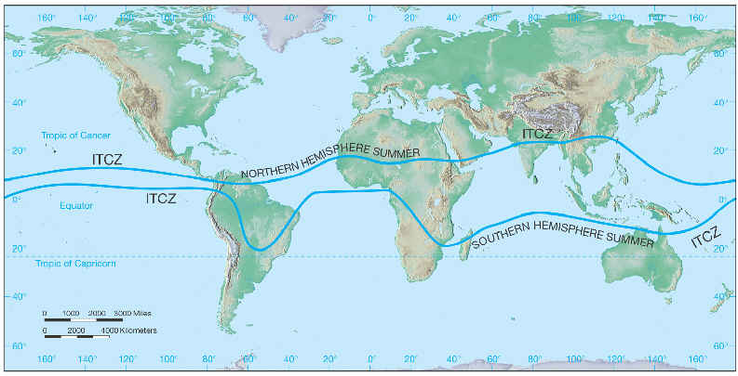

Figure 1. A map indicating the location of the ITCZ depending on the southern or northern hemispheric summer.

The Indian Monsoon season occurs between June through September. In January, it is winter in the northern hemisphere, therefore, the ITCZ recedes into the Southern Hemisphere. During the Northern Hemisphere summer, the ITCZ resides over greater areas of land bringing large amounts of rainfall and seasonal wind shifts in wind direction, especially for India. The shift in wind direction in India brought on by the ITCZ is defined as the Indian Monsoon Season. This definition is often mistaken for heavy rainfall. The Monsoon in the shift in wind directions (figure 2) and the product of the Monsoon is heavy rainfall. The Indian monsoon season covers areas of western and central India typically producing 90% of total annual rainfall amounts.

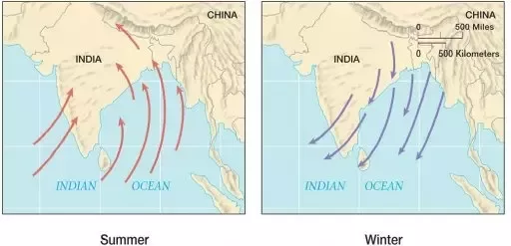

Figure 2. The wind direction over India during the Summer (red) and in the winter (blue).

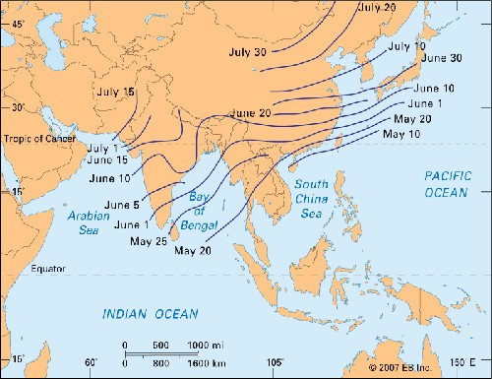

Figure 3. The dates are given for wind the winds reach a certain point.

The Indian Monsoon is a large-scale wind. Therefore, the wind travels faster in some regions more than others. Kerala at the southernmost tip of India, and Andaman and Nicobar Islands in the middle of Bengal Bay are the first to receive rainfall during the monsoon season. This is due to the high velocity of winds influenced by topography. On the other hand, winds more inland are also influenced by topography, but it slows the winds down.

The winds approach from the southwest but can cover a lot of land in shorter amounts of time affecting areas across the Bay of Bengal and other areas in South Asia (Figure 3). The greatest amount of rainfall occurs in Kerala at the southernmost tip of India and the Andaman and Nicobar Islands in the middle of Bengal Bay due to the increased wind speeds.

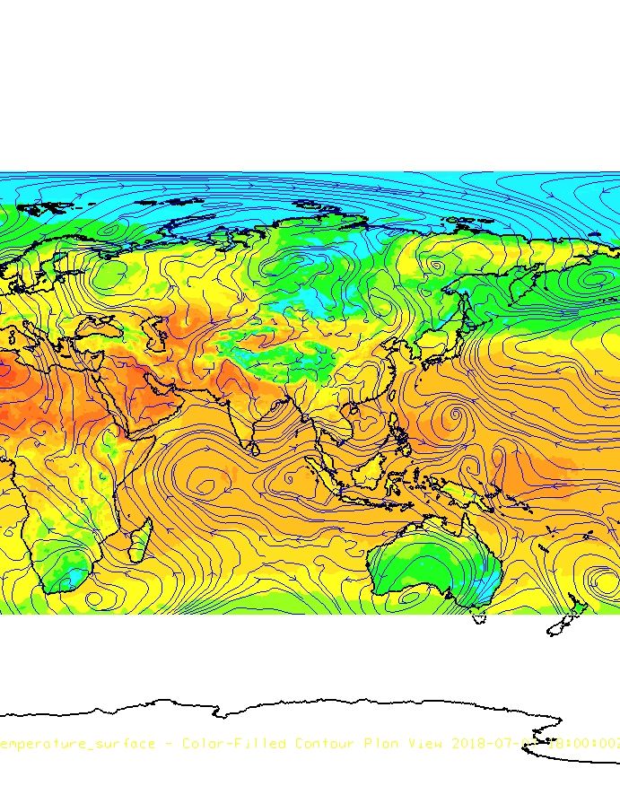

Figure 4. IDV image of surface temperature and 850 mb (blue) during the Indian Monsoon season from July 7th 2018 at 18 UTC.

The Indian monsoon season, and the temperature gradient between the warmer landmass and the cooler ocean can be seen by observing surface temperature (Figure 4). India is visibly warmer than the adjacent water. Along with surface temperatures, streamlines located at 850 mb are showing the direction of wind flow flowing into India and across the Bengal Bay. The ITCZ has shifted into the northern hemisphere; therefore, this shift in wind direction causes India’s monsoon season during the summer months.

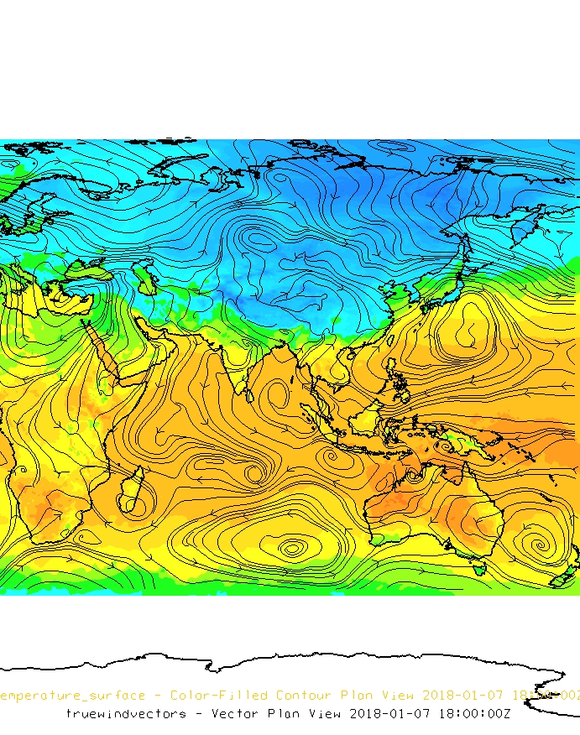

Figure 5. IDV image of surface temperature and 850 mb (black) during the winter from January 1st, 2018 at 18 UTC.

The temperature gradient is weak between the landmass of India and the Arabian Sea during the winter months (Figure 5). The wind flow is in the opposite direction than during the summer (Figure 4). During the northern hemisphere winter, the ITCZ shifts into the southern hemisphere changing moisture and winds patterns influencing the Indian monsoon season.

**2. IDV Project**

Project filename: “IndianMonsoon.xidv”

* Project data:
  + Filename: “gfsanl_4_20180107_1800_000.grb2” & “gfsanl_4_20180707_1800_000.grb2”
  + 0.25°x0.25° Global Forecast System (GFS) analysis data for January 7th, 2018 @ 18Z & July 7th, 2018 @ 18Z File retrieved from NOAA operational model page for select levels and variables:  [NOMADS-NOAA Operational Model Archive and Distribution System](https://nomads.ncep.noaa.gov/)
* Displays:
  + Maps
    - World country outlines.
  + Plan views
    - January 7th, 2018 surface temperature
    - July 7th, 2018 surface temperature
  + Flow displays
    - 850 mb streamlines on January 7th, 2018 and July 7th, 2018.
* Features to note:
  + Figure 4. Land will retain more heat than water in a given amount of time creating larger temperature gradients; therefore, this strong temperature gradient will influence the direction and strength of the winds. The 850 mb streamlines can be seen flowing towards the southwestern coast of India and across Bengal Bay.
  + Figure 5. The temperature gradient is weak. The weak wind flow can be seen by looking at the 850 mb streamlines. In the winter, wind flows the opposite direction.

**3. Knowledge Requirements**

* Module 1-1: Global Temperature Patterns
* Module 1-3: Daily and Seasonal Temperature Variations
* Module 5-1: Overview of Pressure and Wind

**4. Knowledge Test**

Question 1: Define a monsoon.

* A: a torrential downpour of rain
* B: very windy and rainy conditions
* **C: the seasonal change in direction of the strongest wind flow**
* D: the seasonal change in rainfall amounts

Question 2: What influences the Indian Monsoon season?

* A: ENSO
* **B: ITCZ**
* C: Summer temperatures
* D: the seasonal change in rainfall amounts

Question 3: The strongest winds are found on the southwestern coast during the Indian monsoon season, and this is due to:

* A: pressure difference between land and sea
* B: temperature difference between land and sea
* C: large scale land/sea breeze   
  **D: All of the above.**

Question 4: During the Northern Hemisphere ________, India will experience their monsoon season.

* A: Fall
* B: Winter
* C: Spring
* **D: Summer**

Question 5: During the Northern Hemisphere winter, the ITCZ shifts into the ________.

* **A: Southern Hemisphere**
* B: Northern Hemisphere
* C. Western Hemisphere
* D: Eastern Hemisphere

Question 6: The mountain range exists along the western coast of India. What is a result of dry descending air behind this mountain range.

* A: flooding
* B: greenery
* C: more mountains
* **D: desert**

Question 7: What is the name of the sea along the western coast of India?

* A: Red Sea
* B: Dead Sea
* **C: Arabian Sea**
* D: Bengal Bay

Question 8: Where can you find faster wind speeds over greater distances?

* A: Arabian Sea
* B: Mediterranean Sea
* **C: Bengal Bay**
* D: Red Sea

Question 9: The temperature gradient between the landmass of India and the Arabian Sea is stronger in the northern hemisphere ________ and weaker in the northern hemisphere ________.

* A: summer, spring
* B: winter, winter
* C: fall, summer
* **D: summer, winter**

Question 10: Where do the greatest amounts of rainfall occur?

* A: Kerala at the southernmost tip of India
* B: Andaman and Nicobar Islands in Bengal Bay
* C: Thar Desert in western India
* **D: Both A and B**